Name - Cherukuri V V M Subhash

Btech - CSE,3rd year

AI related course work / project / experience: This is my first AI project, and I do not have prior coursework or experience in this field.

# Milestone 1c - Completed

# Mile stone 2 -

The U-Net model was trained using 80 training images and evaluated on 20 test images for semantic segmentation.

* U-Net IoU Score: **8.49%**
* U-Net Dice : **12.8%**

The YOLO model was used for object detection of archaeological structures.

* YOLO IoU Score:
* YOLO Dice Score: Not applicable (YOLO is an object detection model)

# 

# 

# 

# Mile Stone 1 Dataset Collection and Preparation

## **Week 1 Day 1**

**Findings:**

1. We are build an AI system that uses satellite and drone images to help archaeologists:
   1. Identify and segment **ancient ruins** and **vegetation.**
   2. Detect and classify **artifact structures.**
   3. Predict **areas that will face erosion** in the future.
   4. Display all results on an **interactive dashboard**

**Ruins**: Old broken structures built by humans (walls, foundations, temples, ancient buildings).

**Vegetation**: All plant life such as trees, grass, bushes, and forest cover.

**Detect and classify artifact structures** means training an AI model to locate ancient man-made structures in images and automatically identify what type of structure each one is.

**Predicting future erosion zones** means using AI and terrain/environment data to find which parts of an archaeological site are likely to lose soil or get damaged in the future.

| **Aspect** | **Details** |
| --- | --- |
| Objective | To identify archaeological ruins and vegetation from satellite imagery using AI |
| Problem Type | Semantic Segmentation |
| Data Source | Google Earth Pro |
| Output Required | Pixel-wise labeled masks |

**Activities Performed:**

* Studied project problem statement and milestones.
* Understood difference between semantic segmentation and object detection.
* Identified key classes required for segmentation.
* Planned data collection and annotation workflow.

## **Week 1 Day 2**

**Findings:**

I think this 5 datasets helps for preparation for my dataset:

1.**ALOS Landforms** (Global ALOS Landforms)

2.OAM aerial/drone imagery.

3.OAM orthophotos / orthomosaics.

4.DEM / Elevation / Surface Models (GEE).

5.Multispectral / optical satellite imagery (GEE).

| **Aspect** | **Details** |
| --- | --- |
| Tool Used | Google Earth Pro |
| Image Type | Satellite screenshots |
| Format | PNG |
| Variations | Different zoom levels and angles |

**Activities Performed:**

* Explored multiple geographical regions.
* Collected images containing ruins, vegetation, and terrain.
* Ensured variation in scale and viewpoint.
* Saved images systematically.

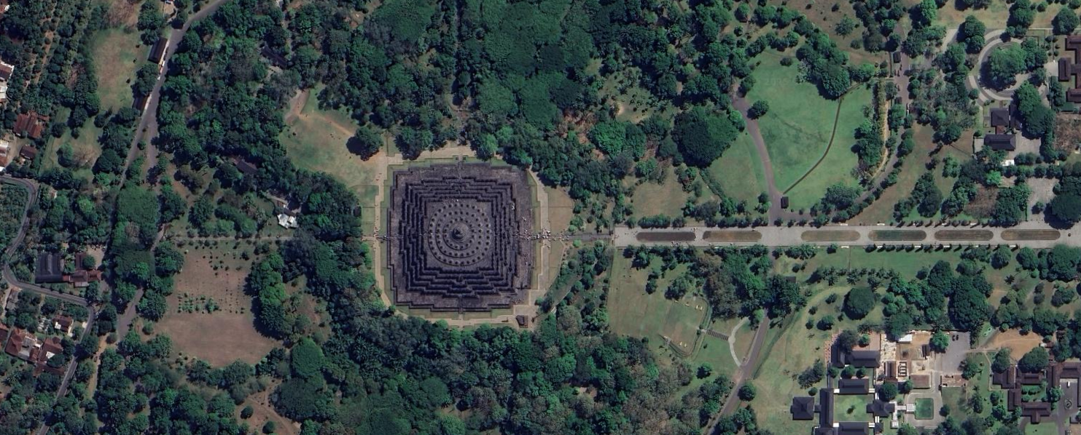

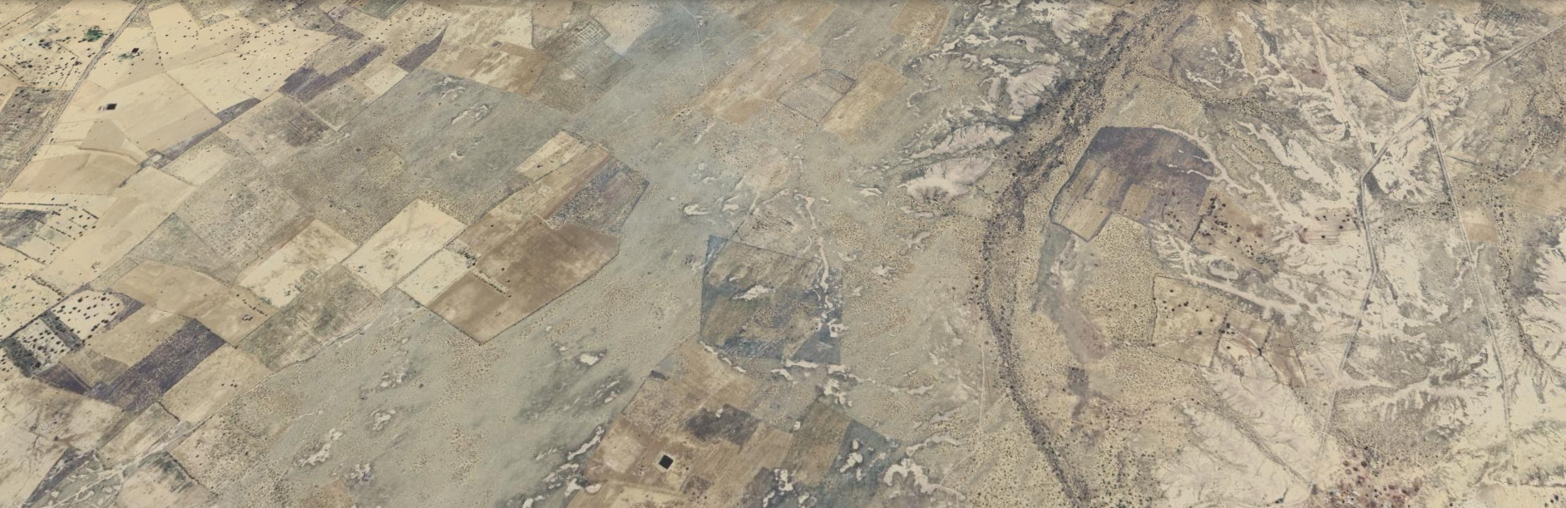

## **Day 3: Dataset Organization & Cleaning**

| **Folder** | **Description** |
| --- | --- |
| ruins | Images with visible archaeological structures |
| vegetation | Images with dense forest/tree regions |
| terrain | Images with open land/background |

**Activities Performed:**

* Organized images into class-based folders.
* Removed unclear, duplicate, or low-resolution images.
* Verified dataset consistency.

## **Day 4: Labelbox Setup & Project Configuration**

| **Aspect** | **Details** |
| --- | --- |
| Annotation Tool | Labelbox |
| Annotation Type | Polygon-based segmentation |
| Classes Defined | Background, Ruins, Vegetation, Terrain |

**Activities Performed:**

* Created Labelbox account.
* Uploaded dataset images.
* Configured segmentation project.
* Defined labeling ontology.  
  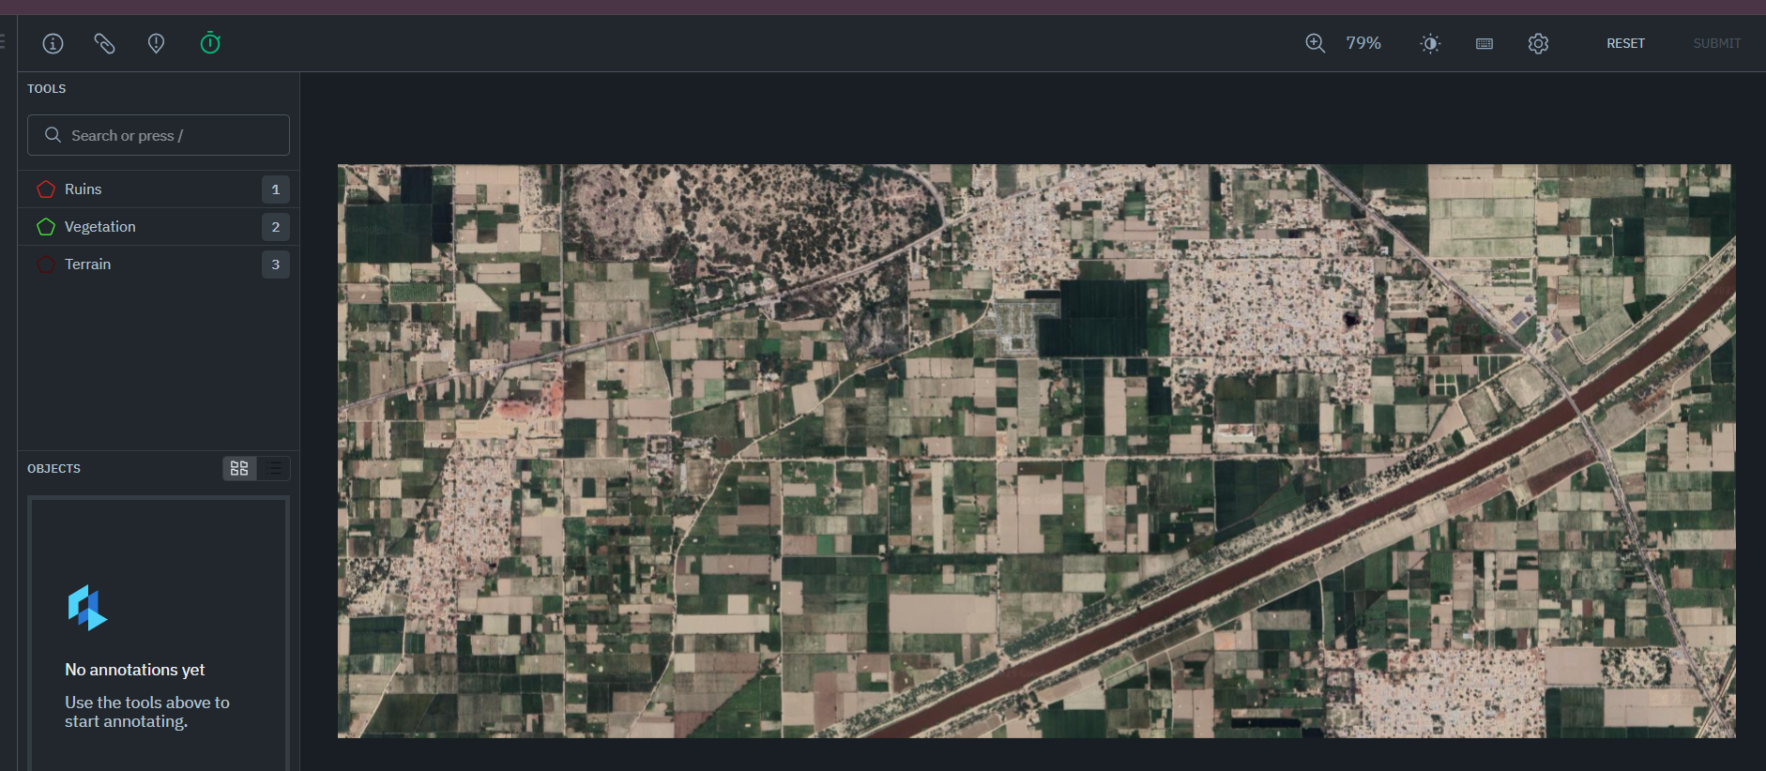

## **Day 5: Initial Image Annotation**

| **Class** | **Labeling Guidelines** |
| --- | --- |
| Ruins | Stone walls, foundations, rectangular structures |
| Vegetation | Dense tree canopy, forest regions |
| Terrain | Open land, non-vegetated areas |

**Activities Performed:**

* Labeled ~12–13 images per class.
* Used polygon tool for precise boundaries.
* Skipped unclear images.  
  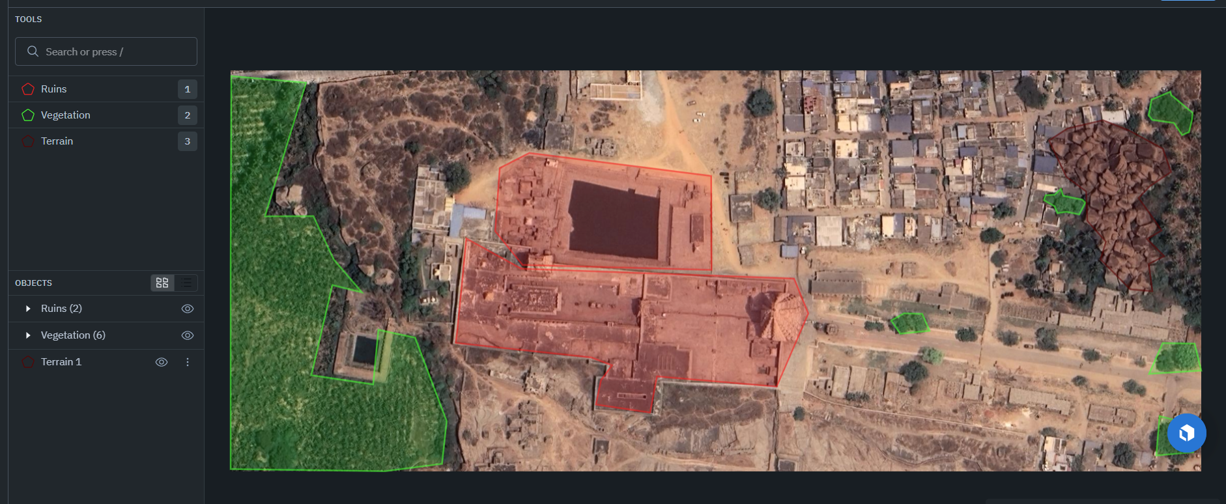

## **Day 6: Annotation Review & Export**

| **Aspect** | **Details** |
| --- | --- |
| Export Format | NDJSON |
| Review Type | Manual verification |

**Activities Performed:**

* Reviewed labeled images.
* Corrected over-labeling and inconsistencies.
* Exported annotations for mask generation.

## **Day 7: Mask Generation & Dataset Split**

| **Task** | **Description** |
| --- | --- |
| Mask Generation | Converted polygons to pixel masks |
| Dataset Split | Train–Validation split |

**Activities Performed:**

* Converted Labelbox annotations to segmentation masks.
* Generated mask images corresponding to each input image.
* Split dataset into training and validation sets.

### **Result of Milestone 1**

| **Outcome** | **Status** |
| --- | --- |
| Satellite dataset collected | Done |
| Images annotated | Done |
| Masks generated | Done |
| Dataset ready for training | Done |

**MILESTONE2: MODEL IMPLEMENTATION, TRAINING & EVALUATION**

## **Day 1: Model Selection & Design**

| **Aspect** | **Details** |
| --- | --- |
| Model Chosen | U-Net |
| Task | Semantic Segmentation |
| Framework | PyTorch |

**Activities Performed:**

* Studied U-Net architecture.
* Selected U-Net for pixel-wise segmentation.
* Planned encoder-decoder structure.

## **Day 2: Dataset Loader & Preprocessing**

| **Task** | **Description** |
| --- | --- |
| Dataset Loader | Custom PyTorch Dataset |
| Preprocessing | Resize, normalize |

**Activities Performed:**

* Implemented dataset loading pipeline.
* Loaded image–mask pairs.
* Verified input dimensions.

## **Day 3: Data Augmentation**

| **Technique** | **Purpose** |
| --- | --- |
| Horizontal Flip | Orientation invariance |
| Vertical Flip | Data diversity |
| Rotation | Robustness |

**Activities Performed:**

* Applied augmentation on training data.
* Increased effective dataset size.
* Improved model generalization.

## **Day 4: Model Training**

| **Parameter** | **Value** |
| --- | --- |
| Optimizer | Adam |
| Loss Function | Cross-Entropy |
| Epochs | 10–20 |
| Hardware | CPU |

**Activities Performed:**

* Trained U-Net model.
* Monitored training loss.
* Saved trained model weights.

## **Day 5: Evaluation Metric Implementation**

| **Metric** | **Purpose** |
| --- | --- |
| IoU | Overlap accuracy |
| Dice Score | Segmentation similarity |

**Activities Performed:**

* Implemented IoU and Dice Score calculation.
* Created evaluation script.
* Loaded trained model for testing.

## **Day 6: Model Evaluation & Results**

| **Class** | **IoU (%)** | **Dice (%)** |
| --- | --- | --- |
| Ruins | 2.43 | 3.63 |
| Vegetation | 7.85 | 9.33 |
| Terrain | 15.20 | 25.44 |
| **Overall Mean** | **8.49** | **12.8** |

**Activities Performed:**

* Evaluated model on labeled data.
* Observed class imbalance effects.
* Analyzed performance limitations.

## **Day 7: Result Analysis & Documentation**

| **Observation** | **Explanation** |
| --- | --- |
| Low IoU for ruins | Limited labeled data |
| Vegetation confusion | Visual similarity with terrain |
| Terrain dominance | Class imbalance |

**Activities Performed:**

* Interpreted results.
* Documented challenges.
* Identified future improvement scope.

### **Result of Milestone 2**

| **Outcome** | **Status** |
| --- | --- |
| U-Net implemented | Done |
| Model trained | Done |
| IoU & Dice evaluated | Done |
| Results analyzed | Done |

**Object Detection using YOLO**

## **Day 1: Understanding YOLO and Its Role in the Project**

| **Aspect** | **Details** |
| --- | --- |
| Topic Studied | YOLO (You Only Look Once) |
| Task Type | Object Detection |
| Difference Studied | Semantic Segmentation vs Object Detection |

**Activities Performed:**

* Studied the concept of **YOLO (You Only Look Once)**.
* Understood how YOLO performs **real-time object detection** using a single neural network.
* Learned the difference between:  
  + **Semantic Segmentation (U-Net)** – pixel-level classification
  + **Object Detection (YOLO)** – bounding box–level detection
* Analyzed how YOLO can be applied to detect **archaeological artifacts and structures** within segmented ruin regions.

## **Day 2: YOLO Architecture and Workflow Study**

| **Component** | **Description** |
| --- | --- |
| Backbone | Feature extraction network |
| Neck | Feature aggregation |
| Head | Bounding box and class prediction |

**Activities Performed:**

* Studied YOLO architecture components.
* Learned how YOLO divides images into grids.
* Understood prediction of:  
  + Bounding boxes
  + Object confidence
  + Class probabilities
* Reviewed YOLOv5 pipeline.